Project Planning Phase
ISTR — Product Backlog, Sprint Planning, Stories, Story Points

Date | 12/09/2026
Student Name | Navya Sri Tangellamudi
Project Name | ISTR — Incident/Service Task Routing
Maximum Marks | 5 Marks
This phase translates the ISTR requirements and design into an executable Agile delivery plan. Work is organized into Epics and Stories, sized using Story Points, and scheduled across Sprints so that progress and team capacity (Velocity) can be tracked objectively. This document expands on the standard planning template with supporting diagrams — the delivery cycle, the epic/story breakdown structure, the sprint timeline, story-point distribution, and sprint burndown — so that the plan is traceable both as data and as a visual narrative.

Purpose
- Break the ISTR scope into manageable Epics and Stories that can be delivered incrementally.
- Estimate relative effort for each Story using Story Points, enabling consistent sprint-to-sprint comparison.
- Establish a delivery cadence (Sprints) and measure team Velocity to guide future planning.
- Visualize scope, schedule, and progress so risks and dependencies are easy to spot early.

Core Concepts
Sprint: a fixed period or duration in which a team works to complete a set of tasks. ISTR uses 6-day sprints.
Epic: a large task or project that is too big to complete in one sprint, broken down into smaller Stories delivered across multiple sprints.
Story: a small, deliverable unit of work that is part of an Epic, written from the user's perspective.
Story Point: a number representing the effort a story takes to complete, typically drawn from the Fibonacci series (1, 2, 3, 5)
— very easy, normal, moderate, and difficult tasks respectively.
Velocity: the average number of story points a team completes per sprint, calculated as Total Story Points Completed ÷ Number of Sprints.
Definition of Done (ISTR): a story is Done when the underlying ServiceNow configuration (table/field, Flow, Business Rule, or report widget) is built, unit-tested on the Personal Developer Instance, and demoed in the Sprint Review.

Agile Delivery Process
ISTR is delivered through a repeating Scrum cycle: items groomed into the Product Backlog are pulled into Sprint Planning, built during Sprint Execution, demoed at Sprint Review, and the process is inspected at the Sprint Retrospective before the next cycle begins.

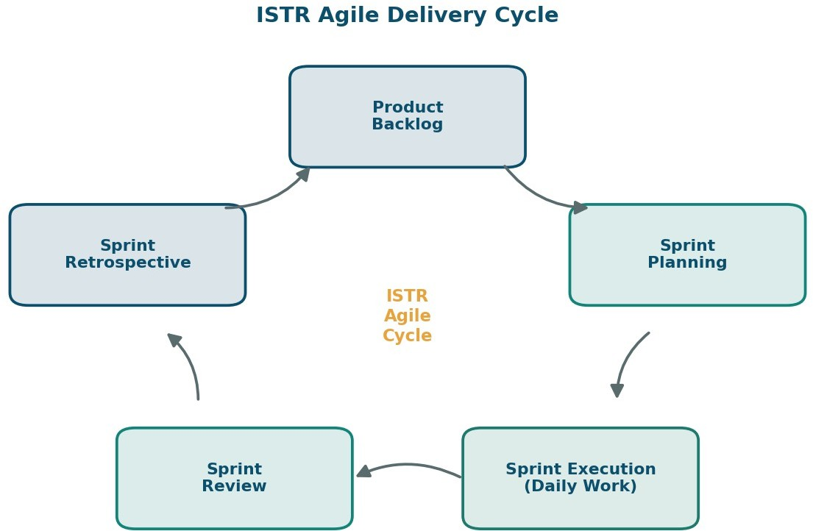

Figure 1 — ISTR Agile Delivery Cycle

Epic & Story Breakdown Structure
The ISTR backlog is organized into 5 Epics and 11 Stories, shown below as a breakdown structure. Sprint 1 covers the data-foundation epics (Collection, Preparation); Sprint 2 covers the presentation-layer epics (Visualization, Dashboard, Story).
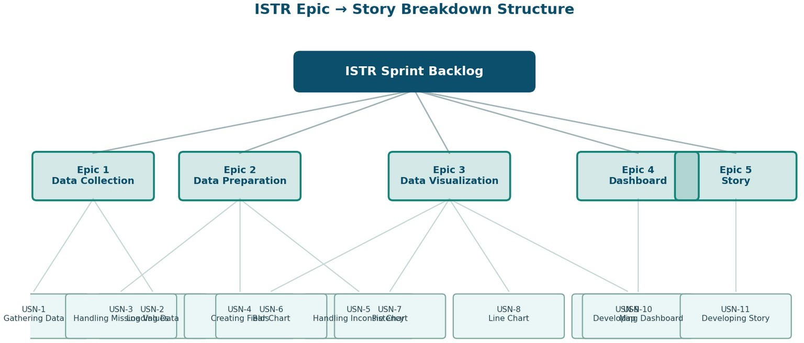

Figure 2 — ISTR Epic → Story Breakdown Structure

Product Backlog, Sprint Schedule, and Estimation (4 Marks)
The table below breaks the ISTR scope into Epics and Stories, written from the user's perspective, with an effort estimate (Story Points), delivery priority, and sprint assignment.

Sprint | Functional Requirement (Epic) | User Story Number | User Story / Task | Story Points | Priority | Team Members
Sprint-1 | Data Collection | USN-1 | As a user, I want data to be gathered from source systems so that it is available for preparation. | 2 | High | [Team]

Sprint | Functional Requirement (Epic) | User Story Number | User Story / Task | Story Points | Priority | Team Members
Sprint-1 |  | USN-2 | As a user, I want the gathered data loaded into the working environment so that it is ready for processing. | 1 | High | [Team]
Sprint-1 | Data Preparation | USN-3 | As a user, I want missing values in the dataset handled so that analysis results are reliable. | 3 | High | [Team]
Sprint-1 |  | USN-4 | As a user, I want new derived fields created from the raw data so that additional insights can be captured. | 3 | Medium | [Team]
Sprint-1 |  | USN-5 | As a user, I want inconsistencies in the data corrected so that the dataset is accurate for downstream use. | 3 | Medium | [Team]
Sprint-2 | Data Visualization | USN-6 | As a user, I want to view a bar chart of key metrics so that I can compare values at a glance. | 2 | Medium | [Team]
Sprint-2 |  | USN-7 | As a user, I want to view a pie chart of category-wise distribution so that I can understand proportions. | 2 | Low | [Team]
Sprint-2 |  | USN-8 | As a user, I want to view a line chart of trends over time so that I can track changes. | 2 | Medium | [Team]
Sprint-2 |  | USN-9 | As a user, I want to view a map visualization so that I can understand geographic patterns in the data. | 4 | Low | [Team]
Sprint-2 | Dashboard | USN-10 | As a user, I want an interactive dashboard so that I can monitor all key metrics in one place. | 5 | High | [Team]
Sprint-2 | Story | USN-11 | As a user, I want a narrative data story so that insights are easy to communicate to stakeholders. | 5 | Medium | [Team]

Sprint Timeline
Each sprint runs 6 days with a short buffer before the next sprint starts, giving time for review, retrospective, and backlog refinement.
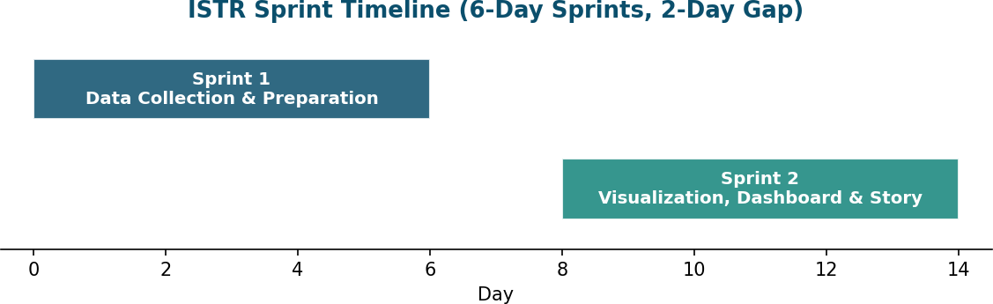
Figure 3 — ISTR Sprint Timeline

Story Point Distribution by Epic
Data Visualization carries the heaviest load (10 points across 4 stories), consistent with it covering four distinct chart types; Dashboard and Story are the highest-priority single-story epics in Sprint 2.

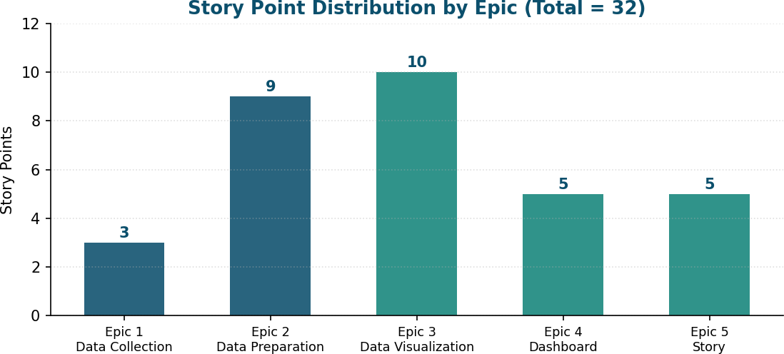
Figure 4 — Story Points by Epic

Sprint Goals
Sprint 1 Goal: Establish a clean, complete dataset — data is gathered, loaded, and free of missing values or inconsistencies before any visualization work begins.
Sprint 2 Goal: Turn the prepared data into decision-ready output — charts, an interactive dashboard, and a narrative story that stakeholders can act on.

Project Tracker, Velocity & Burndown Chart (4 Marks)

Sprint | Total Story Points | Duration | Sprint Start Date (Planned) | Sprint End Date (Planned) | Story Points Completed (as on Planned End Date) | Sprint Release Date (Actual)
Sprint-1 | 12 | 6 Days | 02 Jun 2025 | 07 Jun 2025 | 12 | 07 Jun 2025
Sprint-2 | 20 | 6 Days | 09 Jun 2025 | 14 Jun 2025
Velocity Calculation: Average Velocity (AV) per iteration unit (story points per day) is calculated as:
AV = Velocity ÷ Sprint Duration
For ISTR: AV = 16 ÷ 6 = 2.67 story points per day (based on an average velocity of 16 points/sprint across 2 sprints, each 6 days).
Burndown Charts: work remaining versus time for each sprint. Sprint 1 is actual (completed); Sprint 2 is the projected pace needed to close out its 20 points on schedule.
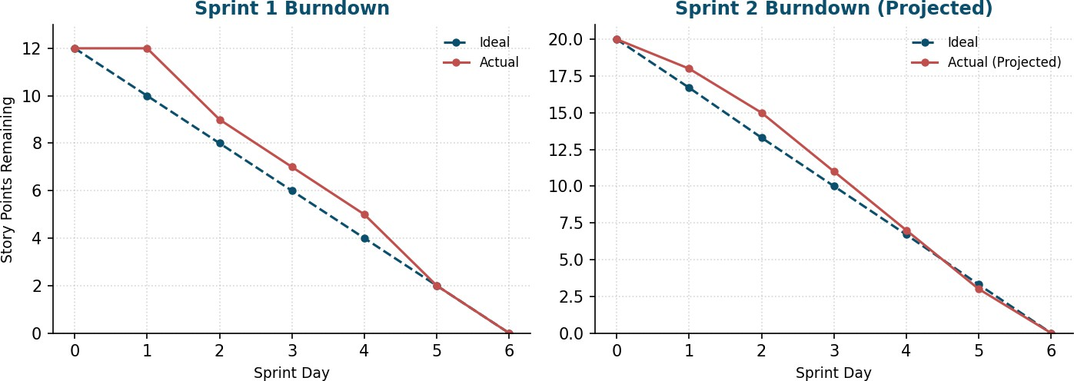
Figure 5 — Sprint 1 (Actual) and Sprint 2 (Projected) Burndown

Risks & Mitigations
- Map visualization (USN-9, 4 points) is the single largest story in Sprint 2 — flagged Low priority so it can slip a sprint without blocking the Dashboard or Story deliverables.

- Dashboard (USN-10) depends on all four Sprint 2 chart stories being functionally complete — sequencing charts before dashboard assembly within the sprint mitigates this.
- Data quality issues found late (post Sprint 1) would cascade into every Sprint 2 visualization — mitigated by dedicating 3 of 5 Sprint 1 stories to data preparation.

Reference
- Atlassian — Agile Project Management
- Atlassian — How to do Scrum with Jira Software
- Atlassian — Epics
- Atlassian — Sprints
- Atlassian — Estimation
- Atlassian — Burndown Charts
- Visual Paradigm — Scrum Burndown Chart

